Lesson Plan Title

Subject:  Related Subjects: | Grade Level(s):  Length of Lesson: | Type: Inquiry / Design / Project  Keywords:

Lesson Overview
Students will use their knowledge about circuits to discover a new property related to electricity: magnetism. Electricity and magnetism are inherently related and the manipulation of electricity will also cause a change in magnetism and vice versa.

Lesson Focus
- The students will use their circuitry knowledge to manipulate magnetism
- The project gives students more experience with circuits
- While the specifics of electricity and magnetism will not be taught, their relation will be demonstrated

Lesson Objective(s) | The students will use what they know about circuits to discover a new property of electricity. Students will:  - Discover a relationship between electricity and magnetism  - Understand magnetism and a few of its properties  - Be able to build a circuit that induces magnetism  - Learn a little about magnetic wire and how to work with it

Lesson Timing

5 minutes | Introduce the Lesson
30 minutes | ...

Materials | - Nails  - Washers  - Wires  - Magnetic Wires  - Wire Strippers  - Battery Holders  - Batteries  - Sandpaper  - NO Pushbutton Switches  - Electrical Tape  - Metal objects (brass fasteners, paper clips, nuts & bolts, coins)
Instructor Prep | - Step 1
Related Resources | - List related lessons/ppts etc available from USC or outside, trusted orgs

Lesson Plan

Introduction
Introduce students to the learning goals and make connections to past and present learning experiences. Stimulate interest and prompt students to identify their own questions about the topic. This can link the lesson to real world examples, introduce associated STEM careers, and assess their prior knowledge on the topic.

- Step 1

Procedure
- The students will first prepare their magnetic wire. They are unfamiliar with the new wire so they will have to take some time to prepare them.
- The students will then construct their circuits using this new wire and a switch of their choice.
- They will wrap the mag wire around a nail, and test the induced magnets.
  - They will test with more loops, fewer loops, bigger loops, smaller loops, etc.
- The students will then test if other materials are magnetic at all (fasteners, paper clips, nut and bolts, coins)
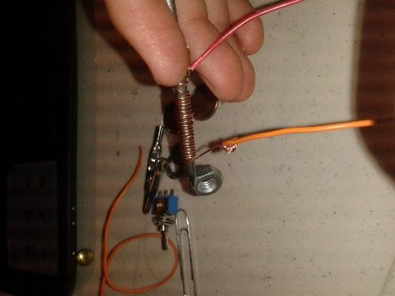

Wrap-up
End the lesson with some final discussions about what students designed/discovered. Connect their activity back to the focus question/problem, real world examples, and STEM careers.

Also include notes about any special cleanup considerations

Lesson Background for Teachers

Suggested Real-World STEM Connections
- List possible related Role Models in STEM (with details and links to more reading). Give suggestions for examples of scientists/engineers who are from underrepresented groups in STEM in related careers.
- List related real-world engineering problems and examples

Lesson Variations and Options
Include descriptions of alternative methods or ways to present things.

Explanation
Describe the background concepts and explanations behind the lesson. This can be more in depth than a teacher/instructor would actually share with students.

Key Concepts and Vocabulary
- Word 1: Grade Appropriate Definition
- Word 2: Grade Appropriate Definition

Safety Notes
- Safety instruction

